# **MRD Template**

Spring 2024

# Name of Product:

List all students who **actively** worked on this MRD Report:

1. Name: Aayushie Suresh Vairagade
2. Name: Aditi Mahendra Joshi
3. Name: Jigar Naik
4. Name: Pratik Patil
5. Name: Shivani Ravindra Kedar

## Vision

For Northeastern University students who struggle to select courses and professors due to insufficient insights, Subject Spotlight is a comprehensive platform that provides detailed course information, professor reviews, and peer recommendations. Unlike existing fragmented solutions, we offer a centralized source of trusted, community-driven content.

## Motivation

### Customer Segments

On a high level, we have the target segments as below.

* Northeastern University’s Students
* Northeastern University’s Alumni

Northeastern University Students:

* Northeastern University Students: This large group (approximately 45,000 students) seeks reliable information to make informed course and professor choices, optimizing their academic experience and supporting their aspirations within Northeastern. Additionally, this segment will provide reviews to help their peers make informed decisions about course selection.
* Transfer Students: These students face unique challenges with unfamiliar course options and a lack of established peer support. They need comprehensive resources to understand the nuances of Northeastern's offerings and make successful academic transitions.
* Students Looking to Change Majors/Minors: This segment requires in-depth information and peer insights to explore new academic paths. They need guidance evaluating potential courses, professors, and the overall impact that a major or minor switch might have on their academic journey.

Northeastern Universities Alumni

* Northeastern Alumni: This segment comprises former graduates who are motivated to give back to the Northeastern community by sharing their valuable academic experiences. They have unique insights into courses, professors, and career paths within their majors. Their knowledge is crucial for helping current students navigate their academic choices

*Early Adopters*: Likely to be students highly engaged in their academics, proactively seeking to optimize their learnings, and comfortable with technology and sharing feedback online. They might be transferring students facing a pressing need for information, or students dissatisfied with their current course selection process.

*Mainstream Users:* Over time, the platform's value should become evident to the broader student body, particularly those making major course decisions or looking to explore new academic areas.

### Unmet Needs

* **Need for Efficient Course Comparison**: "We believe Northeastern students experience difficulty efficiently comparing courses, especially in terms of difficulty, workload, and overall value."

**Evidence:** Our analysis mentions students actively discussing grading patterns (80%), course worth (80%), and an interest in understanding course difficulty. This suggests a desire to easily compare courses side-by-side on these factors.

* **Need for Up-to-Date & Trend-Aware Information:** "We believe Northeastern students want access to current, trend-aware information on courses and professors, as it relates to evolving industry needs."

**Evidence:** 40% of students emphasize the importance of course relevance to future employment and industry trends. This indicates the need for reviews and insights that reflect current industry demands.

* **Need for Personalized Guidance:** “We believe Northeastern students desire a platform that offers tailored course and professor recommendations based on their individual goals and learning styles."

**Evidence:** The survey highlights a strong focus on finding courses that match student interests and the desire to find the "right" professor. This implies a need for a system that goes beyond general reviews and helps students find their best fit.

Note: For evidence refer Appendix

### Existing Solutions

* Uloop: Uloop is a platform offering anonymity and unlimited character input for users to rate professors and discuss courses. The platform requires users to navigate through three pages to reach information, which may be cumbersome for users looking for quick access. Notable for its clarity, Uloop does not offer a comparison feature, which may be a limitation for those looking to compare different educational options. Available as both an app and a website, it may not meet the specific needs of business schools in managing MBA applications due to its lack of customization.
* Koofers: Koofers provides a platform with similar features to Uloop, such as anonymity and no character limit for content, but stands out with its schedule maker tool, which could be useful for planning academic schedules. The information on Koofers is more accessible, requiring only one page to reach. However, like Uloop, it lacks a comparison feature and is only available via a website, not an app. This platform may not fully cater to the customization and functionality required for the MBA application process.

* Reddit: Reddit, a platform that allows for anonymous discussions and threads, does not offer professor ratings. It is available on both app and website platforms. Given its format of information being spread across three pages and the lack of specialized educational tools, it is not an ideal solution for graduate management education applications or data management.
* Rate My Professor: Rate My Professor is a website that allows for anonymous professor ratings. It has a 350-character limit for reviews and requires navigating through two pages to reach information. Although it provides a comparison feature, it is not an application management system and does not support a customized application process for MBA programs.

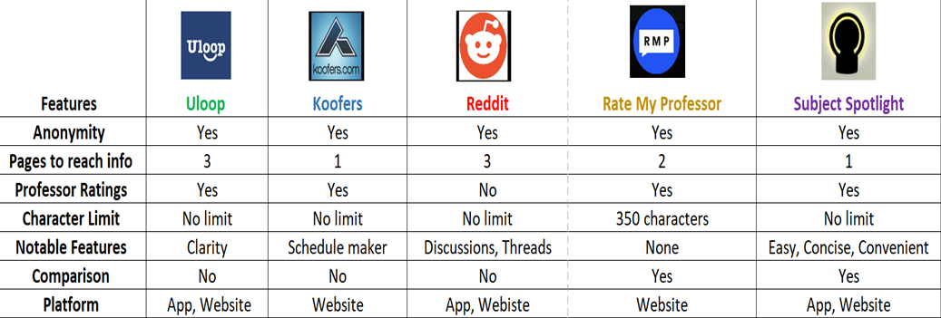

### Differentiation

Subject Spotlight is the ultimate tool for informed course and professor selection. We prioritize ease of use, putting essential information directly at your fingertips. Our features like anonymity, unlimited review space, and professor ratings empower you with honest student feedback. Accessible on both our app and website, Subject Spotlight ensures reviews come from verified students, safeguarding the integrity of the information. We support alumni contributors with FAQ templates, allowing them to provide detailed, valuable insights. Subject Spotlight is your essential resource for achieving academic success.

### Why Now?

Both external and internal changes make this opportunity uniquely available now. Externally, there's strong market demand for a reliable course and professor information platform, as students are increasingly frustrated with existing options. This aligns with the growing trend of student empowerment. Internally, we now have the potential to tap into the valuable knowledge of our alumni network. Additionally, our university is prioritizing data-driven decision-making and better student outcomes, our solution directly supports those goals. These factors combined make this the ideal time to pursue this product.

## Use Cases

*Use Case 1: Finding the Right Professor*

Problem: Alice feels stuck in her current major and needs a class that sparks excitement. She's heard good and bad things about certain professors, making the choice harder.

How subject spotlight helps:

* Alice searches Subject Spotlight for a topic she finds interesting (ex: "Intro to Design").
* Results show courses, and she clicks on one with intriguing content.
* Course page has a detailed syllabus AND several professor profiles for those who teach it.
* Reviews are filterable - Alice focuses on "Engaging Teaching Style" and "Inspiring."
* One professor stands out, with students praising their passion and interactive approach. Alice feels confident enrolling in their section.

*Use Case 2: Prepping for a Tough Class*

Problem: Surya’s advisor recommended a notoriously difficult economics class. He's anxious and wants to prepare.

How subject spotlight helps:

* Surya searches Subject Spotlight for the specific course name.
* Review summaries highlight the workload ("Lots of reading") and specific challenges ("Exams focus on theory, not memorization").
* Surya clicks on "Top Study Tips" (a feature populated by upperclassmen) and sees advice on time management and how to tackle the textbook.
* Feeling more informed, he looks at the syllabus to confirm if he's ready for the commitment

*Use Case 3: Bugged by juniors about the classes to be taken*

Problem: Prachi is an alumnus but has a widespread network of friends and during the days of subject registration is spammed by juniors for help although she wants to help them she is too busy.

How subject spotlight helps:

* Prachi searches Subject Spotlight about the course she has taken.
* She posts a review with the general FAQs she is asked about the course and professor.
* Prachi being the helpful person she is adds study tips and how to get great grades and perform well in the subject.
* When she is approached by someone, she shares them the link to Subject Spotlight for their questions and doesn't feel guilty about not being able to help.

*Use Case 4: The Recent Graduate Giving Back*

Problem: Emily just graduated and feels a sense of gratitude for a particular professor who transformed her academic path. She wants to share her positive experience to help others but lacks a structured way to do so.

How Subject Spotlight Helps:

* Emily receives an email reminder from Subject Spotlight to review her recent courses.
* She excitedly selects the professor's course and sees a streamlined review form.
* She highlights his engaging lectures, valuable feedback on assignments, and the mentorship he provided.
* Subject Spotlight suggests tags like "Challenging but Rewarding" and "Helped me find my Major," which Emily feels are accurate.
* Knowing her review will guide future students fills Emily with a sense of purpose

## Market Size

The total addressable market includes over 25,000 NEU students, with potential expansion to other universities. Preliminary estimates suggest a potential annual market opportunity of $93,600 from advertising and data licensing.

* **Advertising:**

**Assumptions:**   
1. Potential customers: 45,000 Northeastern students

2. Active users: 25,000

3. Activity on App: 3 sessions per month

4. Average time spent: 3minutes per session

5. No. of ads displayed per minute: 4

6. Revenue Per Mille (RPM): $3

**Ad impressions Per Month**

Users: 25000  x 3 Sessions Per Month on Average  x 3 Minutes Spent Per Session

= 225,000 (Total time spent on the app)

225,000x 4 Ads Per Minute

**=** 900,000

900,000 Ad impressions x $3 RPM / 1000

**= $ 2,700**

**Ad impressions Per Year**

= $ 2,700 x 12

**= $ 32,400**

* **Data Licensing:**

**Assumptions:**

1.Types of licenses: Course information; Professor information; Student information

2.Number of licenses sold: 3

3.Price for course information license: $700

4. Price for professor information license: $500

5. Price for student information license: $500

* Monthly Total from Data Licensing = Number of Data Licenses Sold x Price per License

= 3x1700

**= $5,100**

* Annual Total = **$61,200**

**Total Annual Market Potential =** **$ 32,400 + $61,200**

**= $ 93,600**

## 

## Caveats / Risks / Key Dependencies

## Strategic Considerations

Subject Spotlight seamlessly aligns with our university's strategy. By promoting informed student decision-making, it has the potential to improve course satisfaction, reduce time wasted in mismatched classes, and boost overall academic success. Existing solutions are fragmented and unreliable, whereas Subject Spotlight's comprehensive professor information fills a crucial gap. Its focus differs from other competitor sites like Rate My Professor, Reddit, Uloop, and Koofers, offering a unique and valuable tool to enhance student experiences and outcomes.

## Team Members

1. Name: Aayushie Suresh Vairagade ([vairagade.a@northeastern.edu](mailto:vairagade.a@northeastern.edu))

Role: Product Marketing Manager

1. Name: Aditi Mahendra Joshi ([joshi.aditima@northeastern.edu](mailto:joshi.aditima@northeastern.edu))

Role: Product Manager

1. Name: Jigar Naik ([naik.ji@northeastern.edu](mailto:naik.ji@northeastern.edu))

Role: Data Scientist

1. Name: Pratik Patil ([patil.pratik2@northeastern.edu](mailto:patil.pratik2@northeastern.edu))

Role: Full Stack Developer

1. Name: Shivani Ravindra Kedar ([kedar.shi@northeastern.edu](mailto:kedar.shi@northeastern.edu))

Role: Project Manager

## Go/No Go Recommendation

Subject Spotlight isn't just about avoiding bad classes – it's about unlocking a student's full potential. Our platform helps them strategically choose courses and professors that align with their goals and ignite their passion for learning. It's a **GO!** because Subject Spotlight transforms course selection from a roll of the dice into a recipe for academic excellence.

**Appendix:** Applicant survey results

According to our survey we interviewed students from Northeastern University (Boston campus) and categorized the students and alumni, into "buyers" (students seeking course and professor insights) and "sellers" (alumni and seniors offering their experiences). Key points for buyers include challenges in course and professor selection, reliance on peer advice, and interest in a review platform for sharing experiences. Sellers frequently share insights into teaching styles, course relevance, and grading systems, emphasizing practical knowledge and industry alignment. Both groups show a high engagement in information sharing, underlining the value of peer insights in academic decisions.

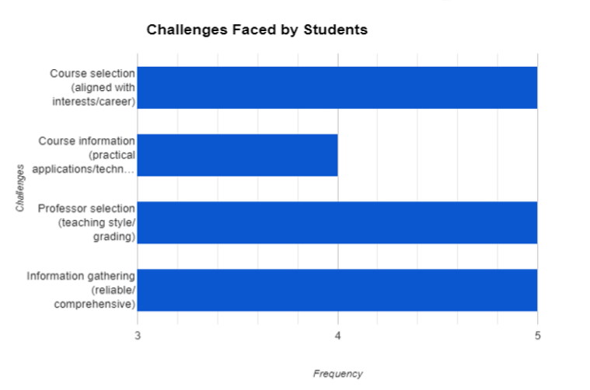

Students actively exchange insights on teaching styles, course value, grading systems, and the practical skills offered by courses, with teaching methods being universally discussed. About 80% of students seek clarity on grading and course benefits, while 60% are interested in the practical knowledge and qualifications gained through their studies. Additionally, 40% emphasize the importance of course relevance to future employment and industry trends. The majority, 80%, frequently inquire about grading patterns and course worth, with 60% focusing on teaching effectiveness and course relevance, and 40% on practical applications.

When it comes to sharing reviews, 90% of students are willing to contribute, particularly if anonymity is guaranteed, although 10% have concerns about privacy and potential fallout. This active participation underscores the significance of peer insights in educational choices and highlights the role of digital platforms in facilitating real-time academic feedback.

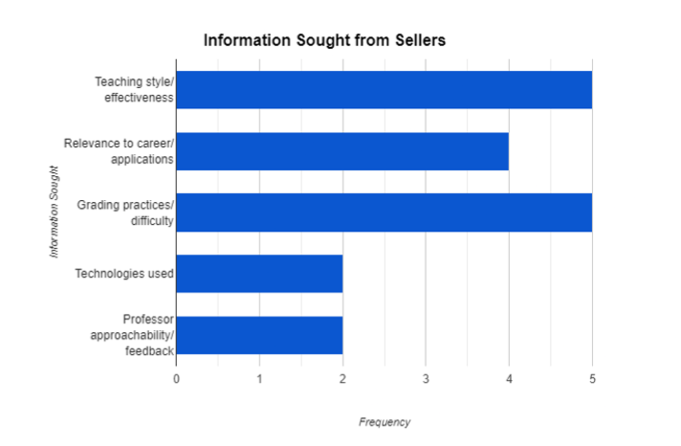

The diagrams below illustrate the preferences and challenges faced by the buyer segment at Northeastern University.

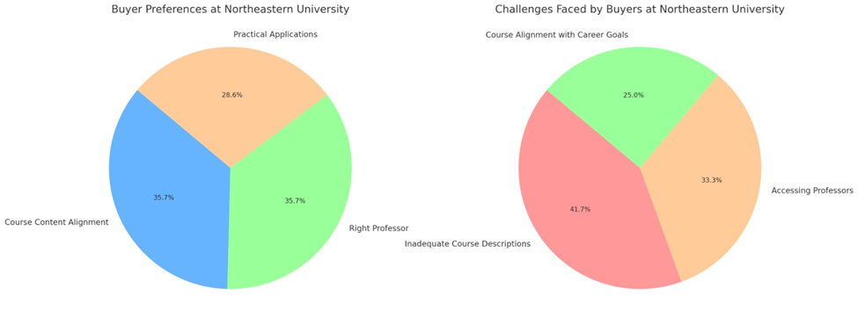

Buyer Preferences: The first diagram highlights the key preferences, showing equal emphasis on course content alignment with interests and finding the right professor, with a significant interest also in understanding the practical applications of courses.

Challenges Faced by Buyers: The second diagram showcases the challenges, with the majority of buyers facing issues with inadequate course descriptions, followed by difficulties in accessing professors, and concerns about the alignment of courses with career goals.

References:

<https://facts.northeastern.edu/#community>

https://www.collegetransitions.com/blog/northeastern-transfer-acceptance-rate-requirements- application-deadlines/#:~:text=Below%20we%20present%20the%20most,admission%20and%201%2C105%20were%20successful